DIS-ME-Syria-Tel Halaf

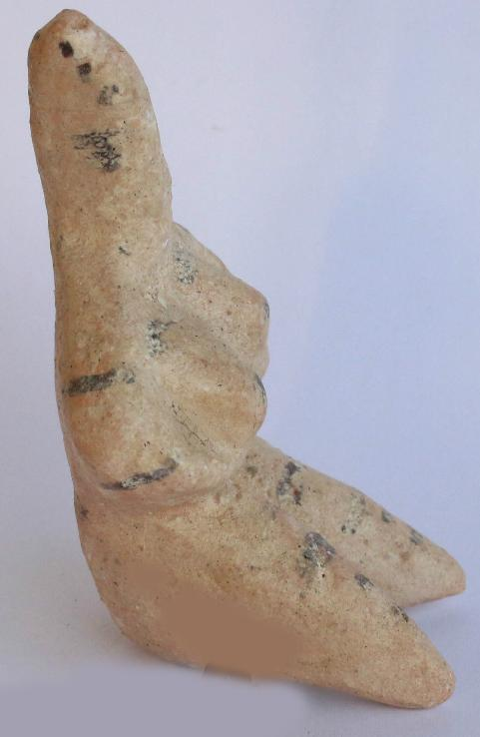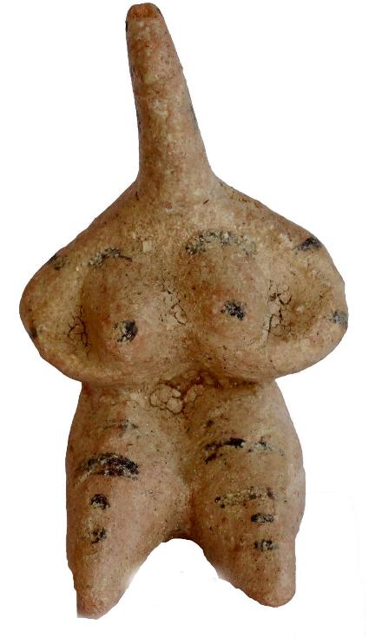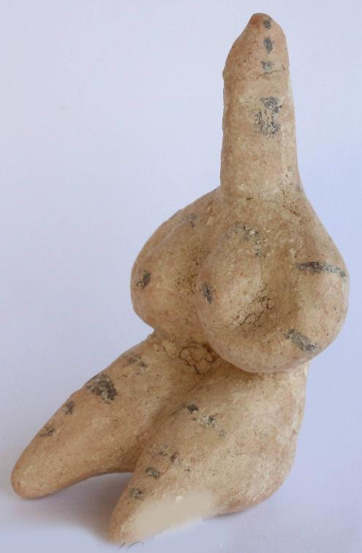

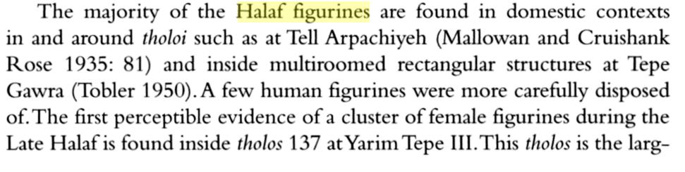 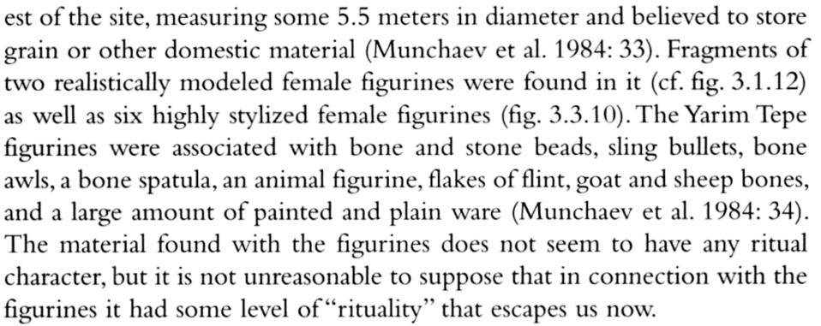

# Order details

Printer friendly page

## Sales order

Sold by [coinauction12](http://myworld.ebay.com/coinauction12) ( [5855](http://feedback.ebay.com/ws/eBayISAPI.dll?ViewFeedback&userid=coinauction12) )

+ Show additional actions

### Delivery package 1 of 1

Estimated delivery Friday, May 20, 2016 -Thursday, May 26, 2016

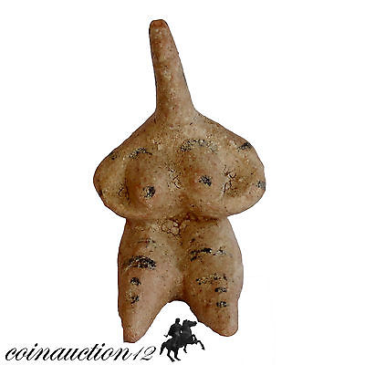

#### [MUSEUM QUALITY TERRACOTTA TEL HALF FEMALE STATUE IDOL 6100-5400 BC](http://www.ebay.com/itm/391452373433)

|  |  |
| --- | --- |
| **Item price** | GBP 65.00 |
| **Quantity** | 1 |
| **Item number** | 391452373433 |
| **Shipping service** | Royal Mail International Signed |

[Contact seller](http://contact.ebay.com/ws/eBayISAPI.dll?FindAnswers&frm=3998&iid=391452373433&redirect=0&requested=coinauction12)

[Return item](http://return.ebay.com/ws/eBayISAPI.dll?ResolveReturn&eventName=viewSelectedItem&TransactionId=0&ItemId=391452373433)

## Shipping address

Ralph J Coffman Jr

149 Atlantic Ave

Swampscott MA 01907-2427

United States

## Order total

|  |  |
| --- | --- |
| **Subtotal** | GBP 65.00 |
| **Shipping** | GBP 9.99 |

**Total**

GBP 74.99

[View PayPal transaction](http://payments.ebay.com/ws/eBayISAPI.dll?UnifiedCheckoutSummaryRedirect2PP&itemid=391452373433&transId=0&buyerorseller=0)

Order placed on

Monday, May 16, 2016

Payment method

PayPal

Payment date

Monday, May 16, 2016